Take two minutes and save a life.
April 2022 - Organ Donation Awareness Month
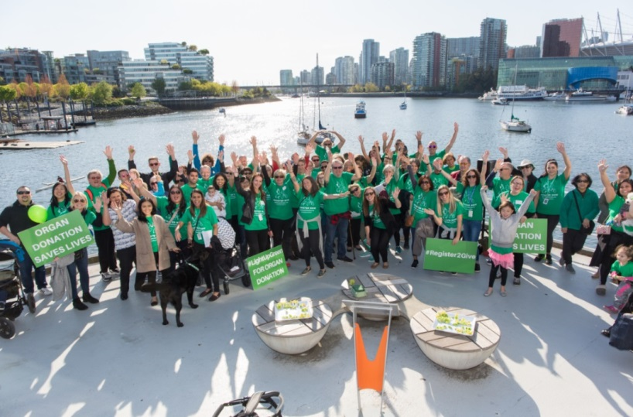
We will be sharing photos from all around the province showcasing their support for organ donation, transplantation and in honour of Logan Boulet. Please email your photos to Irene.Phan@bct.phsa.ca or tag us in your social media.
Facebook @BCTransplant
Instagram @BC_Transplant
Twitter @bc_transplant

Hashtags
#GreenShirtDay
#LoganBouletEffect
#HumboldtStrong
#TakeTwoMinutes
#Register2Give

Key Messages for Twitter, IG and Facebook
April 7, 2022 #GreenShirtDay
- To mark the day Logan Boulet became an organ donor, his family launched #GreenShirtDay on April 7 of every year. Wear green and show your support! #LoganBouletEffect
- DYK? Green is the official colour of organ and tissue donation, symbolizing the hope organ donors provide to patients in need. Wear green on April 7! #GreenShirtDay
- Easy steps for #GreenShirtDay. 1) Wear Green. 2) Take two minutes to register your decision on organ donation. 3) Talk to your family about your wishes.

National Organ and Tissue Donation Awareness Week, April 24-30
- It’s National Organ and Tissue Donation Awareness Week. Talk to your family about organ donation and register your decision. #TakeTwoMinutes
- Talk to your family about organ donation—it’s a conversation that could save up to 8 lives. #TakeTwoMinutes

Campaign
- What takes 2 minutes? Brushing your teeth. Picking a Netflix movie. Registering as an organ donor. #TakeTwoMinutes and register now. Taketwominutes.ca #Register2Give
- Want to feel awesome in less than 2 minutes? Register as an organ donor today. 1 organ donor can save up to 8 lives. Taketwominutes.ca #TakeTwoMinutes.
- Time is everything. This is why we promise registering as an organ donor should only #TakeTwoMinutes. That’s faster than microwave popcorn! #Register2Give
- Do good, feel good! Register to be an organ donor and get that warm fuzzy feeling. 1 organ donor can save up to 8 lives. Taketwominutes.ca #TakeTwoMinutes
- Want an easy win to feel great? Register to be an organ donor today. It will only #TakeTwoMinutes and you could save a life. Great deed and fuzzy feels without any hassle. #Register2Give taketwominutes.ca
- Did you know there are almost 600 people in BC waiting for a transplant? You can give someone great hope by registering your decision today at taketwominutes.ca. 1 organ donor can save up to 8 lives. #Register2Give #TakeTwoMinutes

Links
- April is Organ Donation Awareness Month: http://www.transplant.bc.ca/get-involved/awareness-programs/organ-donation-awareness-month
- Green Shirt Day Resources: http://www.transplant.bc.ca/get-involved/awareness-programs/green-shirt-day-resources
- Register your decision: https://register.transplant.bc.ca/
  - taketwominutes.ca
- Verify your decision: https://register.transplant.bc.ca/verification
- Transplant stories:
  - http://www.transplant.bc.ca/about/news-stories/organ-donation-transplant-stories
  - https://www.youtube.com/channel/UC6t1NM16_2y_HIcnUSQWxVA

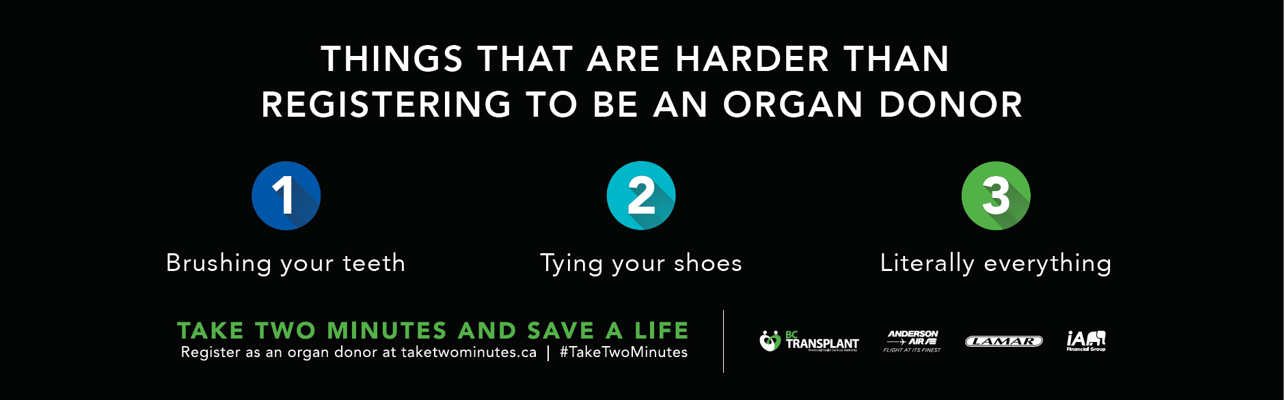
Campaign Graphics
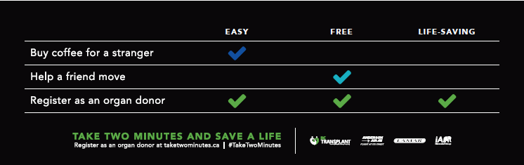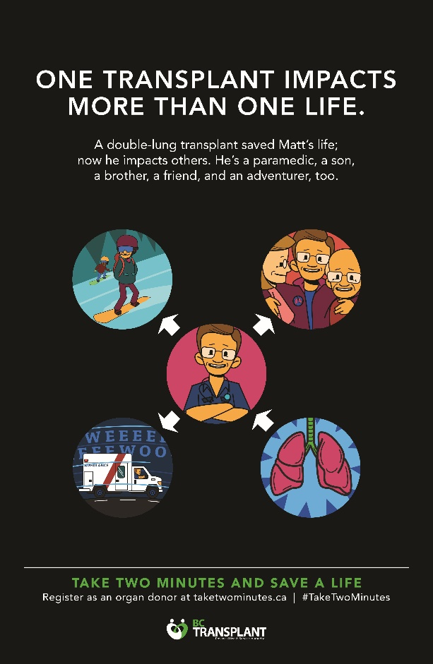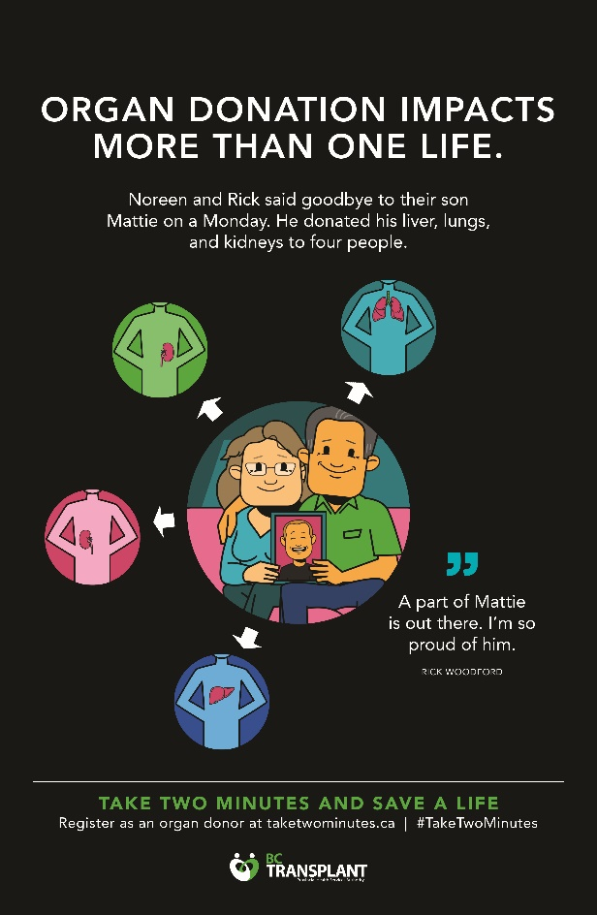

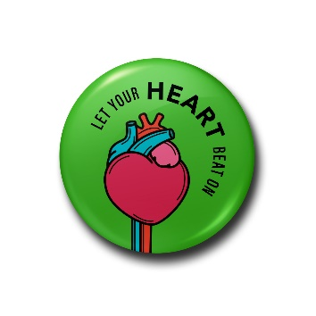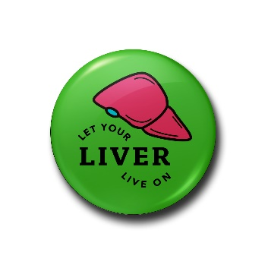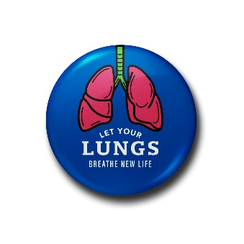

Campaign Photos

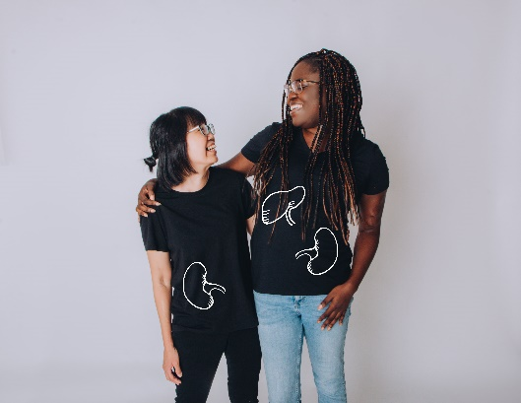
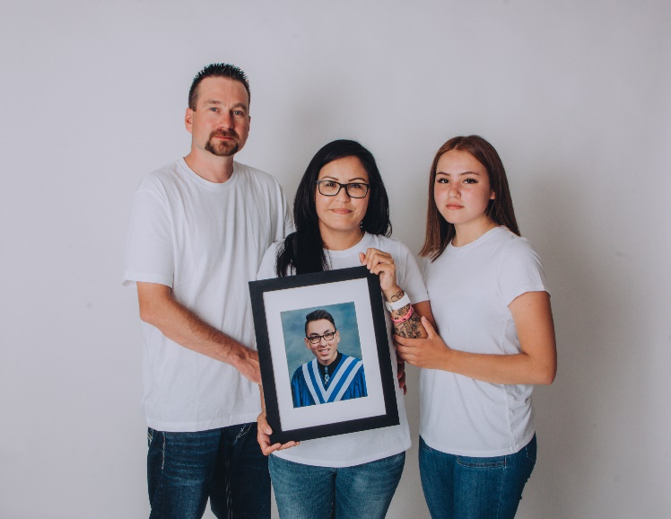
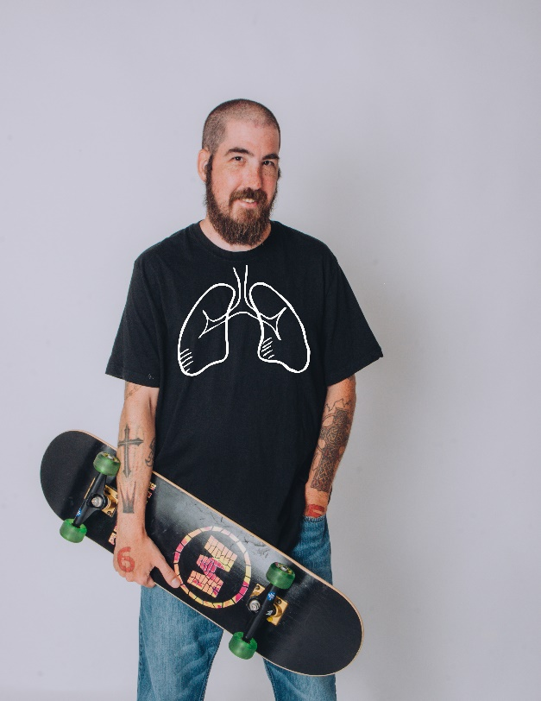

Green Shirt Day Photos
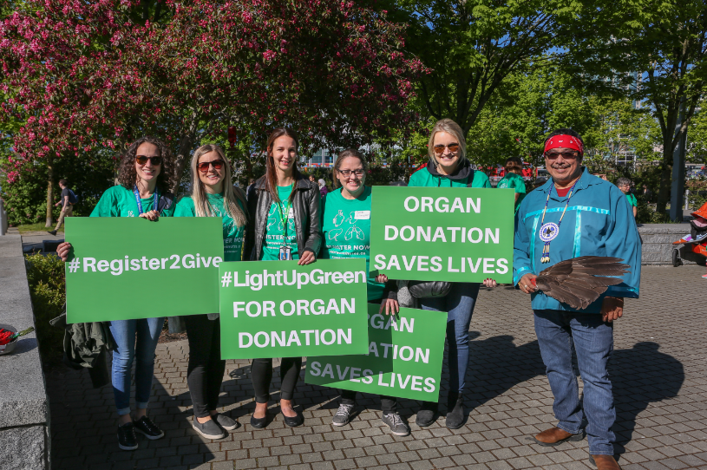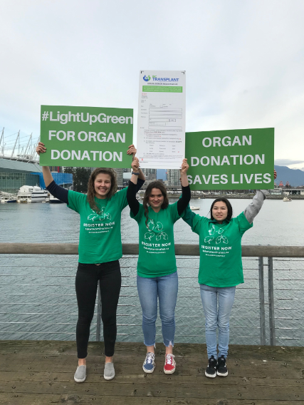

Background: Organ donation and transplant in British Columbia
There are almost 600 British Columbians waiting for a life-saving organ transplant in this province. Almost 80 per cent of patients on the transplant wait list live with chronic kidney disease and are currently on dialysis. Those patients on the wait list for a heart, liver or lungs suffer from a variety of chronic diseases such as cardiomyopathy, polycystic liver disease and cystic fibrosis.

For the people on the transplant wait list, organ donation and transplant gives them a new chance at life – an ability to live a normal life, travel, resume work, and spend time with family. While transplant has a physical impact on each patient, the benefits are felt by a much larger circle of family, friends and community.

Suite 260 • 1770 West 7th Avenue • Vancouver BC V6J 4Y6
Tel: 604-877-2240 • Fax: 604-877-2111 • Toll Free: 1-800-663-6189 • www.transplant.bc.ca

