I never dreamed I'd
live to be an adult.
An organ donor changed that.

- Darvy, double-lung recipient

Register your decision
today!

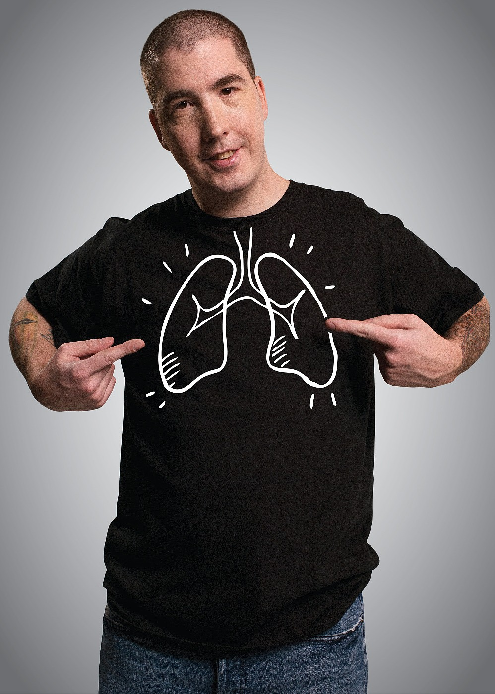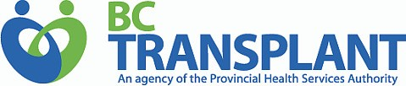Participate in our
registration drive
[date]
[location]

