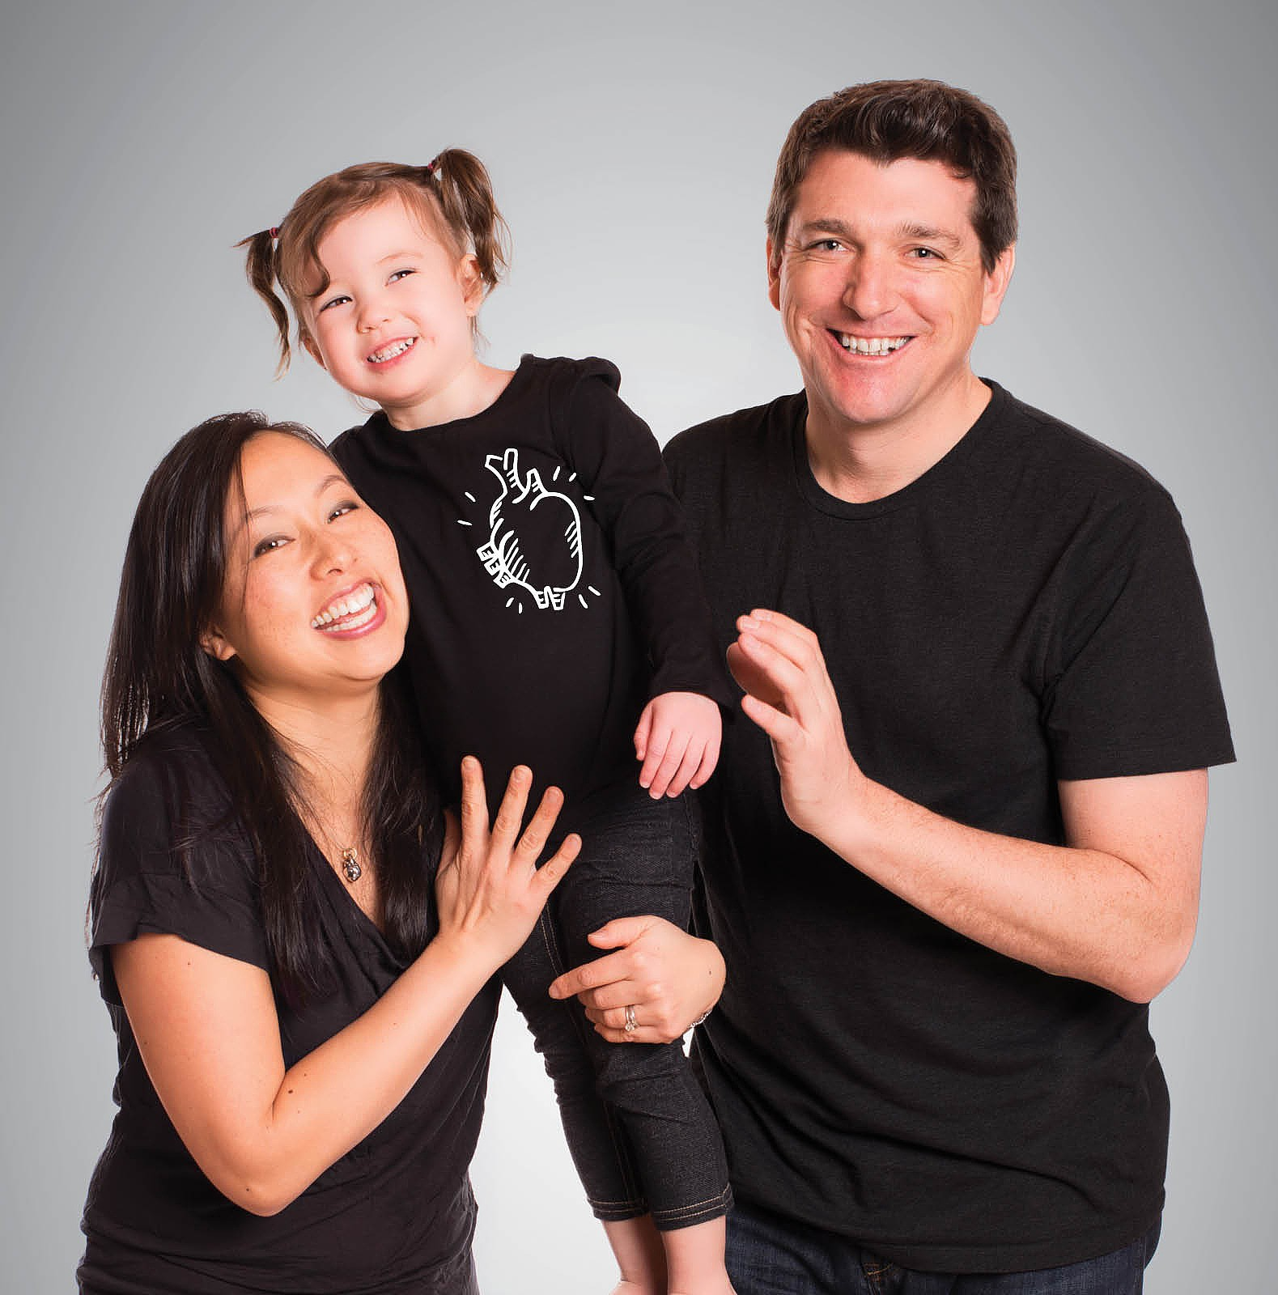We are forever grateful to
the organ donor family that gave us our family

Register your decision
today!

Participate in our
registration drive
[date]
[location]

